

Foundations of Programming

Assignment No.: 18
PROBLEM STATEMENT: Write a C program that accepts a string from the user and performs the following string operations: i) Calculate length of string ii) String reversal iii) Equality check of two strings iv) Check palindrome v) Check substring.

OBJECTIVE:

- To understand basic string operations in C.
- To learn how to manipulate strings using loops and functions.
- To perform comparison, reversal, and substring checking.
- To check whether a string is a palindrome.

THEORY:
In C programming, a string is a sequence of characters terminated by a null character ('\0'). Strings are commonly stored in character arrays. Various operations can be performed on strings such as calculating their length, reversing the characters, comparing two strings, checking whether a string is a palindrome, and finding a substring within another string. These operations can be implemented using loops and conditional statements or by using standard library functions from the string.h header file.
PLATFORM: Linux
CODE:
#include <stdio.h>
#include <string.h>

// Helper function to reverse a string in place
void reverseString(char str[]) {
int n = strlen(str);
for (int i = 0; i < n / 2; i++) {
char temp = str[i];
str[i] = str[n - i - 1];
str[n - i - 1] = temp;
}
}

int main() {
char str1[100], str2[100], sub[100], temp[100];

// Accept the main string
printf("Enter the main string: ");
fgets(str1, sizeof(str1), stdin);
str1[strcspn(str1, "\n")] = 0; // Remove the trailing newline left by fgets

// i) Calculate length
printf("\ni) Length of the string: %lu\n", strlen(str1));

// ii) String reversal
strcpy(temp, str1); // Copy to temp so we don't alter the original string yet
reverseString(temp);
printf("ii) Reversed string: %s\n", temp);

// iii) Equality check
printf("\nEnter a second string for equality check: ");
fgets(str2, sizeof(str2), stdin);
str2[strcspn(str2, "\n")] = 0;

if (strcmp(str1, str2) == 0) {
printf("iii) The strings are equal.\n");
} else {
printf("iii) The strings are not equal.\n");
}

// iv) Check palindrome
// A palindrome reads the same forwards and backwards
strcpy(temp, str1);
reverseString(temp);
if (strcmp(str1, temp) == 0) {
printf("iv) The main string is a palindrome.\n");
} else {
printf("iv) The main string is not a palindrome.\n");
}

// v) Check substring
printf("\nEnter a substring to search for: ");
fgets(sub, sizeof(sub), stdin);
sub[strcspn(sub, "\n")] = 0;

if (strstr(str1, sub) != NULL) {
printf("v) '%s' is a substring of the main string.\n", sub);
} else {
printf("v) '%s' is not a substring of the main string.\n", sub);
}

return 0;
}

INPUT AND OUTPUT:
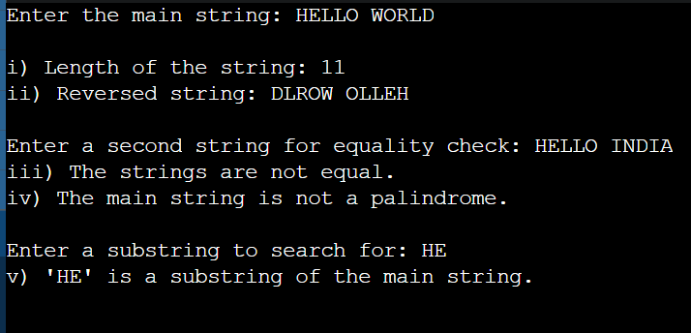
CONCLUSION: Thus, the C program successfully performs different string operations such as length calculation, reversal, equality check, palindrome check, and substring detection.

